The Other Alex
Devin Kadillak, Alex Malott, Alex Shellum, Aaron Thompson, Lucas Wilson
Requirements
- User should be able to register an account using email, nickname, and password.
- User should be able to create a new match but must wait for another player (bot or invited player) to join before playing.
- The user should be able to invite one or more people to join their game.
- The first user to accept the invitation to a game should be chosen to join the game.
- User should be able to reject invitation, and the sender should be notified of either acceptance or rejection.
- User should be able to play multiple games at once.
- Users should also be able to unregister their account.
- Requirement: System should store user match history information (see below) Could wrap this and 10 into player information.
- Requirement: system should store information about games like: players, start and end dates and times, and whether the game ended in a loss, win, or withdraw.
- System should keep info about abandoned games.
- Registered users should be able to view the match history of other players.
- While playing, the rules of the game must be followed.
- The invite invitation remains open only until another player joins.
- The first player to move is the more experienced; if experience is equal, first move goes to the creator of the match.
- The system knows whose turn it is.
- The players can only make a legal move during their turn.
- The state of matches should be saved after user logs out, so that the user can come back to a game and play whenever they want. The other player should be able to make moves while the other player is logged out.
- Users should be informed of if they won or lost, according to the rules of the game.
Extra Requirements
- Users should be able to play against and AI “bot” that can determine what moves to make.
- Users should be able to make a tournament that other users can join.
Use Case Diagram
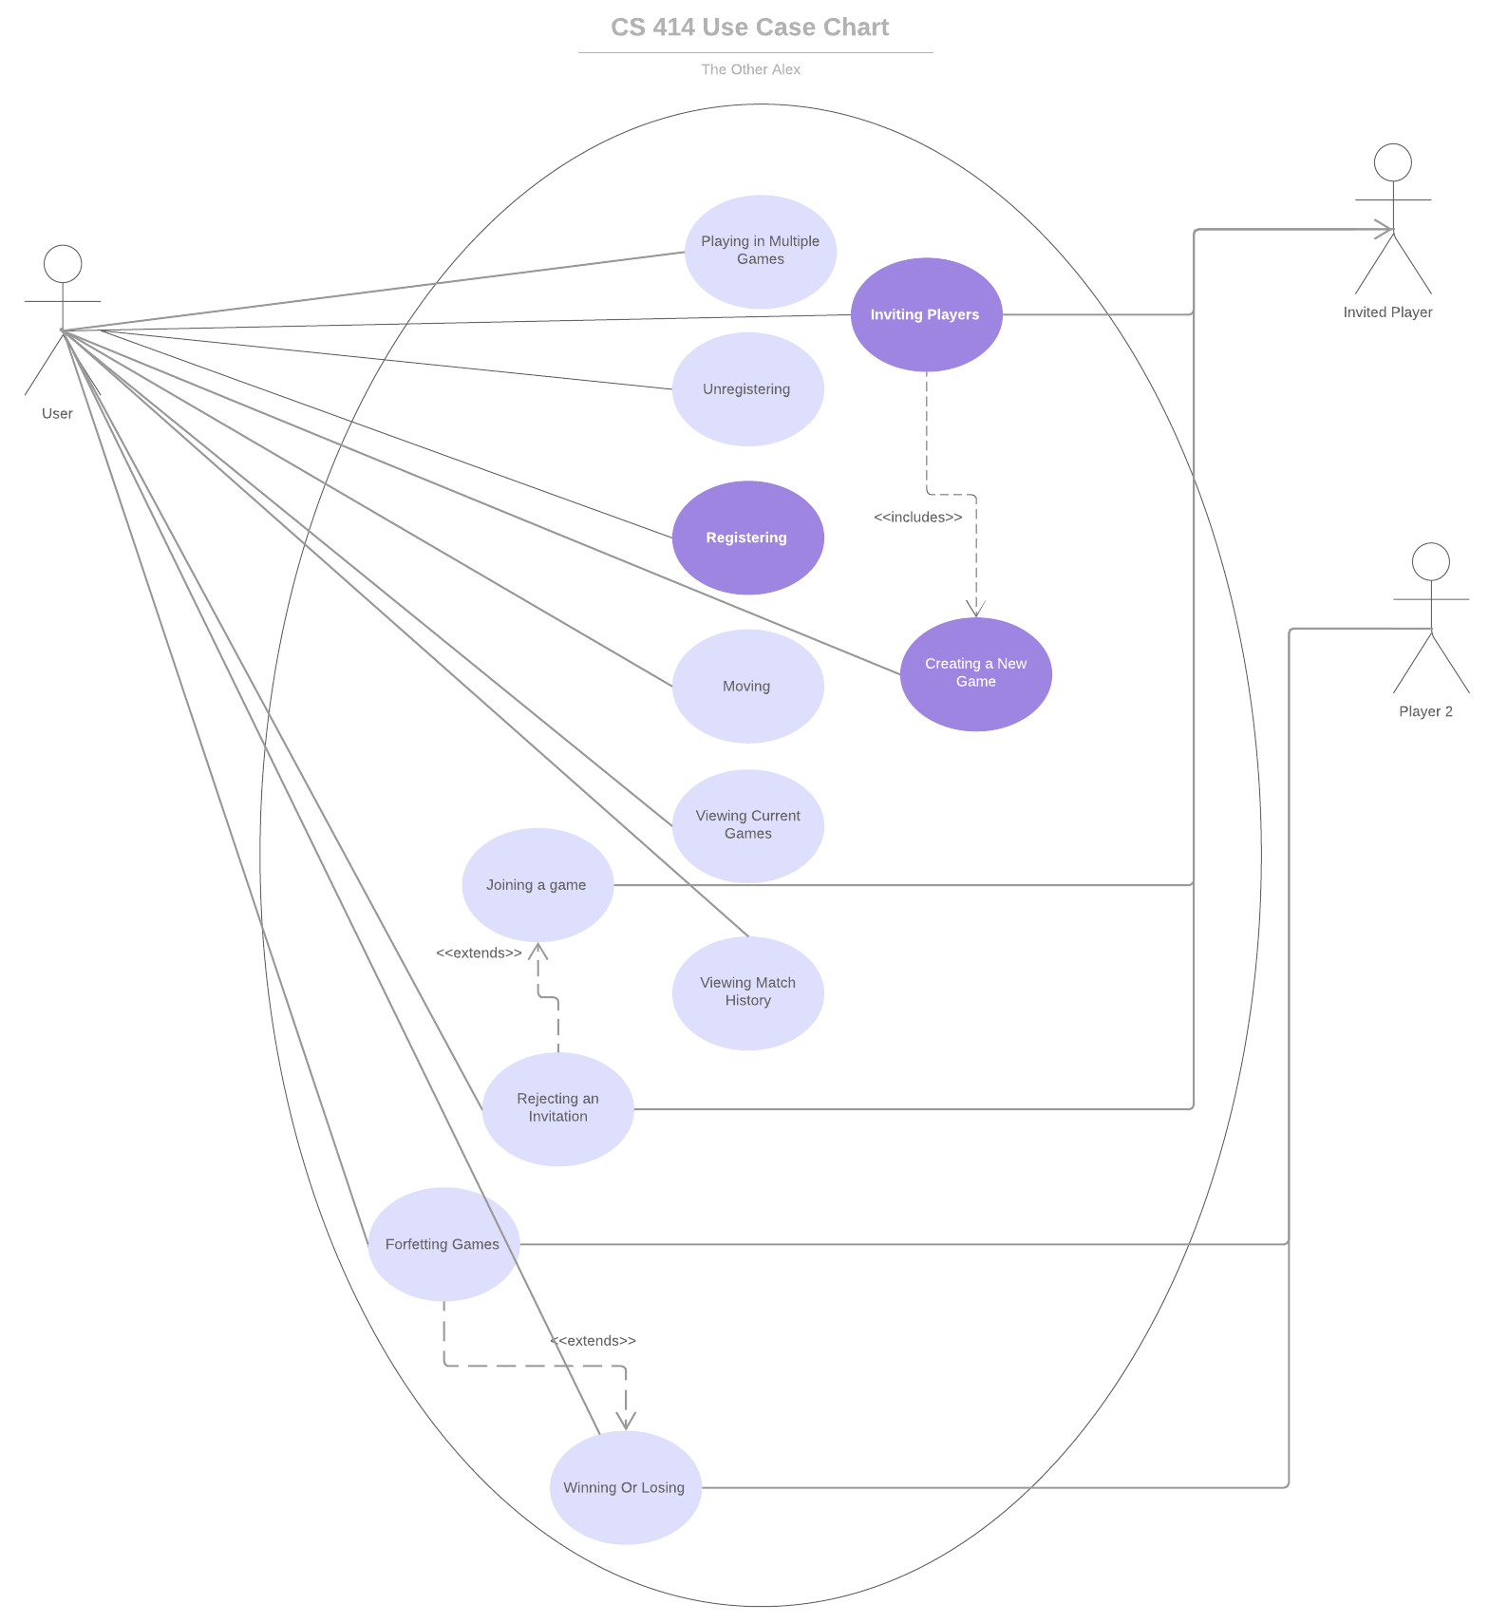
Use Cases
Use case id: | EU-1
Use case name: | Registering
Overview: | The user sets up an account.
Type: | Primary
Actors: | User {Initiator} {primary}
Secondary actors: | N/A
Properties: | Performance: N/A  Security: N/A  Other: N/A
Pre-conditions: | The user should have a valid email address.
Main Flow: | 1) The user is prompted to enter email.  2) The user is prompted to set up a user-name and password.  3) The user becomes registered on the site.
Subflows: | Break down of main flow steps
Alternative flows: | N/A
Post-conditions: | The user now has full access to the system.
Cross references: | N/A

Use case id: | EU-2
Use case name: | Creating a new game
Overview: | The user initiates a new game.
Type: | Primary
Actors: | User {Initiator} {primary}
Secondary actors: | Player 2
Properties: | Performance: N/A  Security: N/A  Other: N/A
Pre-conditions: | The User and Player 2 must be registered in the system.
Main Flow: | 1) The user selects to create new game instance.  2) The user selects auto-forfeit time.  3) The user selects to play against a human or a bot.  4) Game play begins when player 2 joins.
Subflows: | Break down of main flow steps
Alternative flows: | N/A
Post-conditions: | A new game instance is created.
Cross references: | N/A

Use case id: | EU-3
Use case name: | Inviting players
Overview: | The user invites one or more additional players to their game.
Type: | Primary
Actors: | User {Initiator} {Primary} Invited Players {primary}
Secondary actors: | N/A
Properties: | Performance: N/A  Security: N/A  Other: N/A
Pre-conditions: | User has created a game instance.
Main Flow: | 1) The user provides a list of players to invite.  2) The invited players are notified they’ve been invited.  3) An invited player chooses to join the game.  4) Any outstanding invitations are revoked.
Subflows: | N/A
Alternative flows: | Instead of step 3, the user who initiated the invite chooses to cancel it.
Post-conditions: | The invited player is still in the game.
Cross references: | EU-4

Use case id: | EU-4
Use case name: | Joining a game
Overview: | The first invited player to accept an invite joins the game.
Type: | Primary
Actors: | Invited player {Initiator} {Primary}
Secondary actors: | User
Properties: | Performance: N/A  Security: N/A  Other: N/A
Pre-conditions: | A game instance has been created by User and invitations have been sent out.
Main Flow: | 1) The invited player receives the invitation to the user’s game.  2) The invited player accepts the invitation.  3) The invited player joins the user’s game.
Subflows: | N/A
Alternative flows: | 1) The invitation has already been accepted by someone else. Post-condition: Invited player is notified that the game is full.
Post-conditions: | The invited player joins user’s game.
Cross references: | N/A

Use case id: | EU-5
Use case name: | Rejecting invitation
Overview: | The invited players rejects an invitation.
Type: | Primary
Actors: | Invited player {Initiator} {Primary} User {Primary}
Secondary actors: | N/A
Properties: | Performance: N/A  Security: N/A  Other: N/A
Pre-conditions: | A game has been initiated by the user and user has sent invited player an invitation.
Main Flow: | 1) The invited player receives invitation from user.  2) The invited player rejects invitation.  3) The user is notified of invited player’s rejection.
Subflows: | N/A
Alternative flows: | N/A
Post-conditions: | The invited player does not join user’s game. The user’s invitations to other invited players are still active.
Cross references: | N/A

Use case id: | EU-6
Use case name: | Playing in Multiple Games
Overview: | The user is involved in multiple game instances simultaneously.
Type: | Primary
Actors: | User {Initiator} {Primary}
Secondary actors: | Player 2
Properties: | Performance: N/A  Security: N/A  Other: N/A
Pre-conditions: | The user is registered
Main Flow: | 1) The user initiates a game and invites players  2) The user initiates more games and invites players
Subflows: | N/A
Alternative flows: | 1) The user is invited to one or more games by additional players.  2) The user accepts invites  Post-Conditions: User is now a part of all games that they were the first to accept the invitation to.
Post-conditions: | The user is playing in all game instances they initiated that additional players have accepted the invitations to.
Cross references: | EU-4

Use case id: | EU-7
Use case name: | Forfeiting game
Overview: | The user leaves a game by forfeiting.
Type: | Primary
Actors: | User {Initiator} {Primary} Player 2 {Primary}
Secondary actors: | N/A
Properties: | Performance: N/A  Security: N/A  Other: N/A
Pre-conditions: | A game between the user and player 2 is in progress
Main Flow: | 1) The user opts to leave an in-progress game by forfeiting.  2) The user loses game.  3) The player 2 is notified the user has forfeited and the game has ended.
Subflows: | N/A
Alternative flows: | N/A
Post-conditions: | The player 2 wins the game
Cross references: | N/A

Use case id: | EU-8
Use case name: | Unregistering
Overview: | The user unregisters their account.
Type: | Primary
Actors: | User {Initiator} {Primary}
Secondary actors: | N/A
Properties: | Performance: N/A  Security: N/A  Other: N/A
Pre-conditions: | The user is registered.
Main Flow: | 1) The user chooses to unregister their account.  2) The user’s active games are forfeited.
Subflows: | N/A
Alternative flows: | N/A
Post-conditions: | The user’s account and information is deleted.
Cross references: | EU-10 EU-7

Use case id: | EU-9
Use case name: | Viewing match history
Overview: | The user is able to view the match history of a selected user.
Type: | Primary
Actors: | User {Initiator}{Primary}
Secondary actors:
Properties: | Performance:  Security:  Other:
Pre-conditions: | The user is registered.
Main Flow: | 1) The user provides the name of a user.  2) A list of previously played games and aggregate statistics (W/L ratio, ELO) connected to that name is provided.
Subflows:
Alternative flows: | The provided user name is not found – an error message is presented.
Post-conditions:
Cross references: | EU-10

Use case id: | EU-10
Use case name: | Viewing Current Games
Overview: | The user views all active games in which they participate.
Type: | Primary
Actors: | User {Initiator}{Primary}
Secondary actors:
Properties: | Performance:  Security:  Other:
Pre-conditions: | The user has completed registration.
Main Flow: | 1) The user requests their active game information.  2) The user is presented a list of their active games .
Subflows:
Alternative flows:
Post-conditions:
Cross references: | EU-9

Use case id: | EU-11
Use case name: | Moving
Overview: | The user can makes a legal move during their turn.
Type: | Primary
Actors: | User {Initiator} {Primary}
Secondary actors: | N/A
Properties: | Performance: N/A  Security: N/A  Other: N/A
Pre-conditions: | The user has initiated a game and is playing against an opponent.
Main Flow: | 1) User makes a legal move on their turn
Subflows: | 1) For first move, user with most experience goes first.
Alternative flows: | N/A
Post-conditions: | The user’s piece has been moved from its old position to a new one.
Cross references: | EU-9

Use case id: | EU-12
Use case name: | Winning or losing
Overview: | The user is notified if they win or lose.
Type: | Primary
Actors: | User {Initiator} {Primary} Player 2 {Secondary}
Secondary actors: | N/A
Properties: | Performance: N/A  Security: N/A  Other: N/A
Pre-conditions: | A game must be underway.
Main Flow: | 1) Either the user or player 2 makes a move that wins the game.  2) That player is notified that they won, and the other is notified that they lost.
Subflows: | N/A
Alternative flows: | 1) A player forfeits the game. Post-condition: The remaining player receives a win on their record, the forfeiting player receives a loss.
Post-conditions: | The winning player has a win added to their record. The losing player has a loss recorded on their record.
Cross references: | N/A

